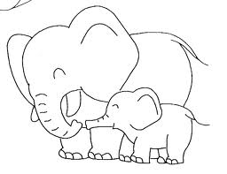

7 x 7 = 49
5 x 6 =
3x 8 =
4 x 9 =

7 x 7 = 30
5 x 6 =
3x 8 =
4 x 9 =

7 x 7 =
5 x 6 =
3x 8 =
4 x 9 = 36

7 x 7 =
5 x 6 =
3x 8 = 24
4 x 9 =

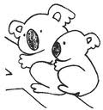

8 x 8 =
8 x 6 = 48
5 x 9 =
3 x 7 =

8 x 8 = 64
8 x 6 =
5 x 9 =
3 x 7 =

8 x 8 =
8 x 6 =
5 x 9 = 45
3 x 7 =

8 x 8 =
8 x 6 =
5 x 9 =
3 x 7 = 21

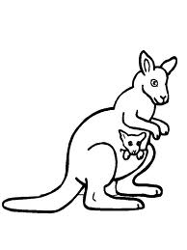

2 x 9 =
4 x 7 = 28
3 x 6 =
2 x 8 =

2 x 9 = 18
4 x 7 =
3 x 6 =
2 x 8 =

2 x 9 =
4 x 7 =
3 x 6 =
2 x 8 = 16

2 x 9 =
4 x 7 =
3 x 6 = 18
2 x 8 =



6 x 6 = 36
7 x 8 =
3 x 9 =
6 x 7 =

6 x 6 =
7 x 8 = 56
3 x 9 =
6 x 7 =

6 x 6 =
7 x 8 =
3 x 9 =
6 x 7 = 42

6 x 6 =
7 x 8 =
3 x 9 = 27
6 x 7 =

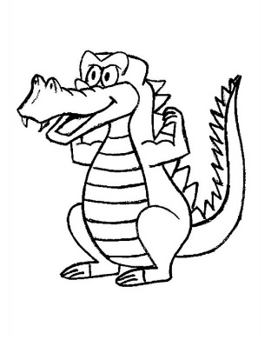

5 x 7 =
8 x 6 = 48
4 x 8 =
6 x 9 =

5 x 7 = 35
8 x 6 =
4 x 8 =
6 x 9 =

5 x 7 =
8 x 6 =
4 x 8 =
6 x 9 = 54

5 x 7 =
8 x 6 =
4 x 8 = 32
6 x 9 =

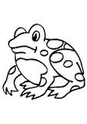

9 x 9 =
2 x 7 =
9 x 6 =
5 x 8 = 40

9 x 9 =
2 x 7 =
9 x 6 = 54
5 x 8 =

9 x 9 =
2 x 7 = 14
9 x 6 =
5 x 8 =

9 x 9 = 81
2 x 7 =
9 x 6 =
5 x 8 =



6 x 8 =
4 x 6 = 24
7 x 9 =
8 x 7 =

6 x 8 = 48
4 x 6 =
7 x 9 =
8 x 7 =

6 x 8 =
4 x 6 =
7 x 9 =
8 x 7 = 56

6 x 8 =
4 x 6 =
7 x 9 = 63
8 x 7 =


7 x 6 =
9 x 8 =
8 x 9 =
9 x 7 = 63

7 x 6 =
9 x 8 =
8 x 9 = 72
9 x 7 =

7 x 6 = 72
9 x 8 =
8 x 9 =
9 x 7 =

7 x 6 = 42
9 x 8 =
8 x 9 =
9 x 7 =

